2 – 4 JUNE 2012

WIMBOTSHAM

EVENTS PROGRAMME

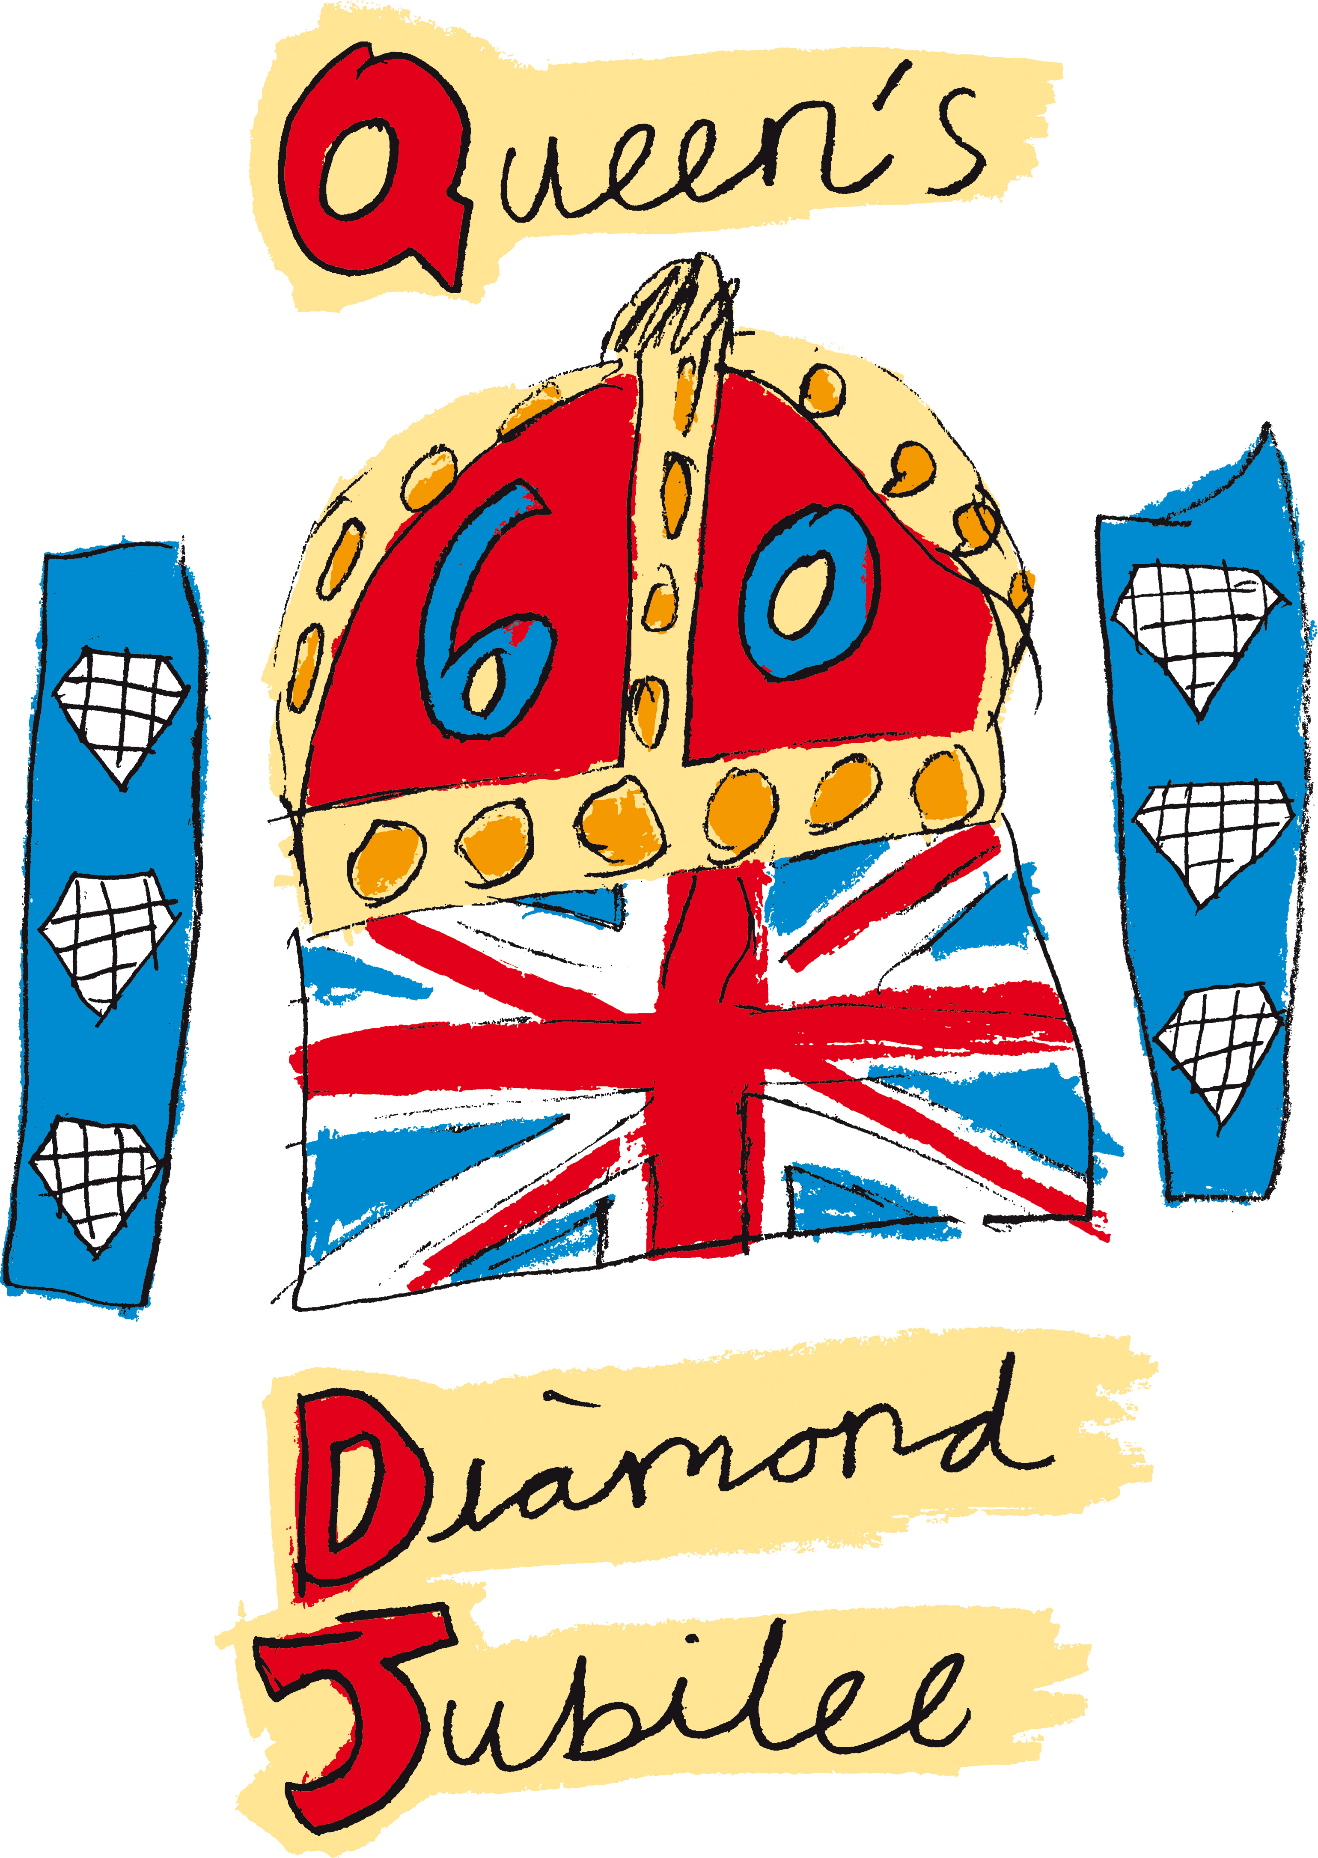

CELEBRATING 60 YEARS OF OUR QUEEN’S REIGN

This celebration is for everyone in the village and the committee want it to be as successful as possible. Let us make it a weekend we can all remember! This will probably be the only Diamond Jubilee any of us will see in our lifetime.

SATURDAY 2 JUNE

Sports Day
On the recreation ground. There will be:
9 events open to 2 – 11 year olds
3 events for 12 – 16 year olds
3 events for Adults

10.30 – 11am Registration
On the recreation ground. Simon Bates or a member of the Recreation Ground committee will sign you up and give you details of where and when your chosen event/s will take place. Last registration at 11am.

11.15am First event starts
Medals and certificates of participation will be awarded to those who come 1st, 2nd & 3rd and will be presented to the successful competitors on Monday 4 June at 6.15pm on the village green. Competitors who were not successful will be presented with a medal and a certificate of participation on the day.
Please note competitors will receive only one medal for participating in the Sports day not per event entered. Free squash will be available for all competitors.

Wimbotsham ‘Bake Off’
12pm Doors open - Registration.
Bring your cake to the small room at the back of the village hall. 1pm Doors shut.

Committee Co-ordinators Steph Smith and Mo Tunwell.

What you need to do
- Bake an 8” cake of your choice.
- Decorate it as you wish to represent the ‘Jubilee’ using only edible decorations.
- Your recipe for the cake to be placed beside the cake for judging purposes.

1pm Judging
The cakes that are judged will then be cut for our pensioners to enjoy at their party (we hope that you do not mind).

Prizes
- There will be 1st, 2nd & 3rd place prizes.
- All entries will receive a certificate of participation.

Prizes and certificates of participation will be awarded on Monday 4 June at 5pm on the village green.

1 – 3pm Teddy Bears Picnic
Will take place on the recreation ground. Bring your own picnic, a blanket to sit on and your Teddy Bear. The Committee will provide jelly, ice cream, squash, will issue flags, gold crowns, a paper crown to colour and some spontaneous prizes and sweets. We also have some apples for you to try.

Committee Co–ordinator Sue Smith.

Competition
- Dress up your Teddy Bear in red, white and blue.
- Write the bears name and your name on a label and attach it to your bear.

Prizes
There will be 1st, 2nd & 3rd place prizes.

Prizes and certificates of participation will be awarded on Monday 4 June at 5.45pm on the village green.

2pm Stalls and Activities
On the village green you will find various stalls, a bouncy castle, a lucky dip, face painting, ice cream van, tractors, horse carriage, horses, tombola, cup cakes and much more. There will be something for everyone to enjoy and take part in.

2 – 4.30pm BBQ
You can buy and enjoy a BBQ provided by the Chequers throughout the afternoon.

Jubilee Raffle
We will be selling tickets all day which will be drawn and the lucky winner announced at 7pm Monday 4 June on the village green.

Music
Will be played throughout the afternoon. Our compere will be Steve Smith.

1952 Quiz
Why not join in our 1952 quiz? Question sheets cost £1 and can be collected from and returned to our compere Steve Smith. The quiz runs all weekend and the prize (winner takes all) will be presented on Monday 4 June at 5.30pm on the village green.

4 – 6pm Pensioners Tea Party
Will take place in the main hall of the village hall. It will be limited to the first forty pensioners who live in Wimbotsham on a first come first served basis. To book a place contact: David Long, 25 Church Road,
Tel 384598, email: longdlb@aol.com

- Join in the raffle.
- Enjoy the music provided by Reg Rose and sing along.
- Tea will consist of sandwiches, sausage rolls, jelly, ice cream and much more.
- Sample the cakes that were entered into the ‘Wimbotsham Bake Off’.
- You will be visited at some stage by Wimbotsham’s very own Queen and Prince Phillip.
- The village hall will be decorated for the Jubilee celebration.
- Enter our competition for the best hat decorated in the Jubilee colours and win a prize.

Committee Co-ordinator David Long.

SUNDAY 3 JUNE

10am – 2pm Children’s Trail Quiz
The trail is around the village and children MUST be accompanied by an adult. Pick up your quiz details from Andy and David who will be sitting outside the Chequers. Cost is £1 per quiz sheet (winner takes all). The quiz will consist of twelve questions and phrases. When you have finished the quiz please return it to Andy and David. Free squash and sweets will be available. The prize will be awarded on Monday 4th June at 5.15pm.

MONDAY 4 JUNE

2pm Stalls and Activities
On the village green again you will find various stalls, a bouncy castle, a lucky dip, face painting, ice cream van, tractors, horse carriage, horses, tombola, cup cakes and much more. There will be something for everyone to enjoy and take part in.

2 – 4.30pm BBQ
You can buy and enjoy a BBQ provided by the Chequers throughout the afternoon.

Prize Giving and Presentations

5pm Wimbotsham Bake Off

5.15pm Children’s Trail Quiz

5.30pm 1952 Quiz

5.45pm Best Dressed Teddy Bear

6pm Queen and Prince Phillip presentation

6.15pm Sports day

6.30pm Presentation of Jubilee mugs to children (for up to 11 years of age)

7pm Raffle drawn by Don Gates

8pm Speech by the
Reverend Karen Burnett-Hall

8.10pm Lighting the Beacon by Don Gates

8.30pm Jubilee celebration cake to be cut by Jean Gates.
Baked by Mo Tunwell.

The ‘Diamond ‘Jubilee Committee wish to thank the following organisations and people for their help and donations:
Accent Fresh (Jan and Frank)
Boots, Downham Market
Borough Council of King’s Lynn & West Norfolk
CFM Entertainments
The Chequers’
Church Farm, Stow Bardolph
Johnsons, Downham Market
Lifeline 4 Chernobyl
Lions Club, Downham Market
Morrison’s, Downham Market
Norfolk County Council
Reeds Furnishings, Downham Market
Sainsbury’s, Kings Lynn
Sergeants Butchers, Stowbridge
Tesco, Downham Market
Wimbotsham Parish Council
Wimbotsham Recreation Committee
Wimbotsham Village School
Wimbotsham Village Shop
Simon Bates
Brian Baylis
Ian Cable
Richard Catchpole
Sarah Cox
Linda and Chick Nixon
Don and Jean Gates
Ian Nurse
Shelley (Community Bus)
Mr and Mrs J Soames - Waring
Mr and Mrs Surridge
Gwen Tester
Mo Tunwell
Mr & Mrs Mike Turner
Everyone who donated food or raffle prizes for the events
All members of the ‘Diamond’ Jubilee Committee
Andy West (Chair), David Long (Vice Chair)
Angie Soames - Waring, Simon Bates, Brian Baylis, Clive Brady,
Mac Burton, Lucy Child, Christine Child, Sarah Cox, Ian Drury,
Dana Frost, Wendy & Mick Grove, Jo Hartley, Rob James, Linda Nixon, Pauline Rotman, Mary Scott, Anne Smith,
Steve, Sue & Stephanie Smith, Jackie Squires,
Linda Surridge, Dennis Surridge,
Mike Taylor & Mrs Ward (Wimbotsham School), Mo Tunwell.
Programme Design Christopher Smith

